Greetings, ladies, and gentlemen of the city council, esteemed members of our community, and passionate advocates for a sustainable future, I stand before you today as a proud volunteer for the Clean Lakes Alliance, a non-profit organization dedicated to the improvement and protection of the Yahara River Watershed. Our mission, to restore and protect our lakes, streams, and wetlands, is not just an environmental cause; it is a commitment to the well-being of our community, our economy, and our future (Clean Lakes Alliance).
Our planet appears mostly blue from space, with an apparent abundance of water. Only one percent of its surface is made up of freshwater, though. It is imperative that the world recognize the worth of freshwater, a finite and precious resource (IUCN, 2021). The Environmental Protection Agency estimates that over $450 billion in manufactured goods, food, fiber, and tourism depend on clean, healthy watersheds. For the sake of you and your community, properly conserving the watershed is therefore essential (The Nature Conservancy n.d.).
The Clean Lakes Alliance is not just another environmental organization. We are a coalition of concerned citizens, businesses, and community groups, united in our effort to protect these vital resources. Our mission is to champion our lakes and watershed stewardship for the benefit of all. Together, our coalition's varied viewpoints and proficiencies strengthen our capacity for creativity and efficient problem-solving with regard to environmental issues. Our unified front strengthens our message and increases our persuasiveness when arguing for public support and policy changes.
However, why should this concern you, the city council, who have a lot of important causes to consider when making budgetary decisions? First, investing in our waterways is an investment in public health. 70% of the Earth is covered in water, although 40–50% of the waters in our country are sadly damaged or in danger (The Nature Conservancy n.d.).
Second, as a UW-Madison student, I know how important lakes are to students. We will not be able to enjoy the new experience of laughing and leaping into the lake with our pals if the top waters are contaminated, swimming in polluted water can cause skin rashes and sting swimmers’ eyes(Better Health Channel, 2003). And it is less fun to rest by the lake when the water quality declines, the birds that populate so many drawings will likewise eventually become extinct.
Third, beyond its support of life-sustaining processes, water is essential to human well-being in many other ways as well, such as mental and spiritual health, emotional stability, and happiness(UNESCO 2021). It has to do with legacy. The fate of humans and water is inextricably linked. In the words of the Whanganui River Tribe's proverb, ‘Ko au te awa, ko te awa ko au’ - I am the river, the river is me. The kind of world we leave for future generations will depend on the actions we take today to safeguard our water.
To those who are still on the fence, I implore you to think about the long-term advantages of funding watershed preservation. This is about sustainable development, economic prosperity, and public health, not just environmentalism. What would befall the next generation if exploitation continues? Perhaps a war over a pail or a glass of water alone would break out? Or a global war between powerful nations over a mere 1/4 of the 1% of freshwater that remains available for them? Be sure to reconsider(The Berkey, 2023).
I'll end by asking you to come along on this important endeavor with us. The Clean Lakes Alliance is a movement rather than just an organization. a movement founded on the idea that access to clean water is a fundamental human right, not an extravagance and that we must work together to safeguard this invaluable resource for present and future generations.

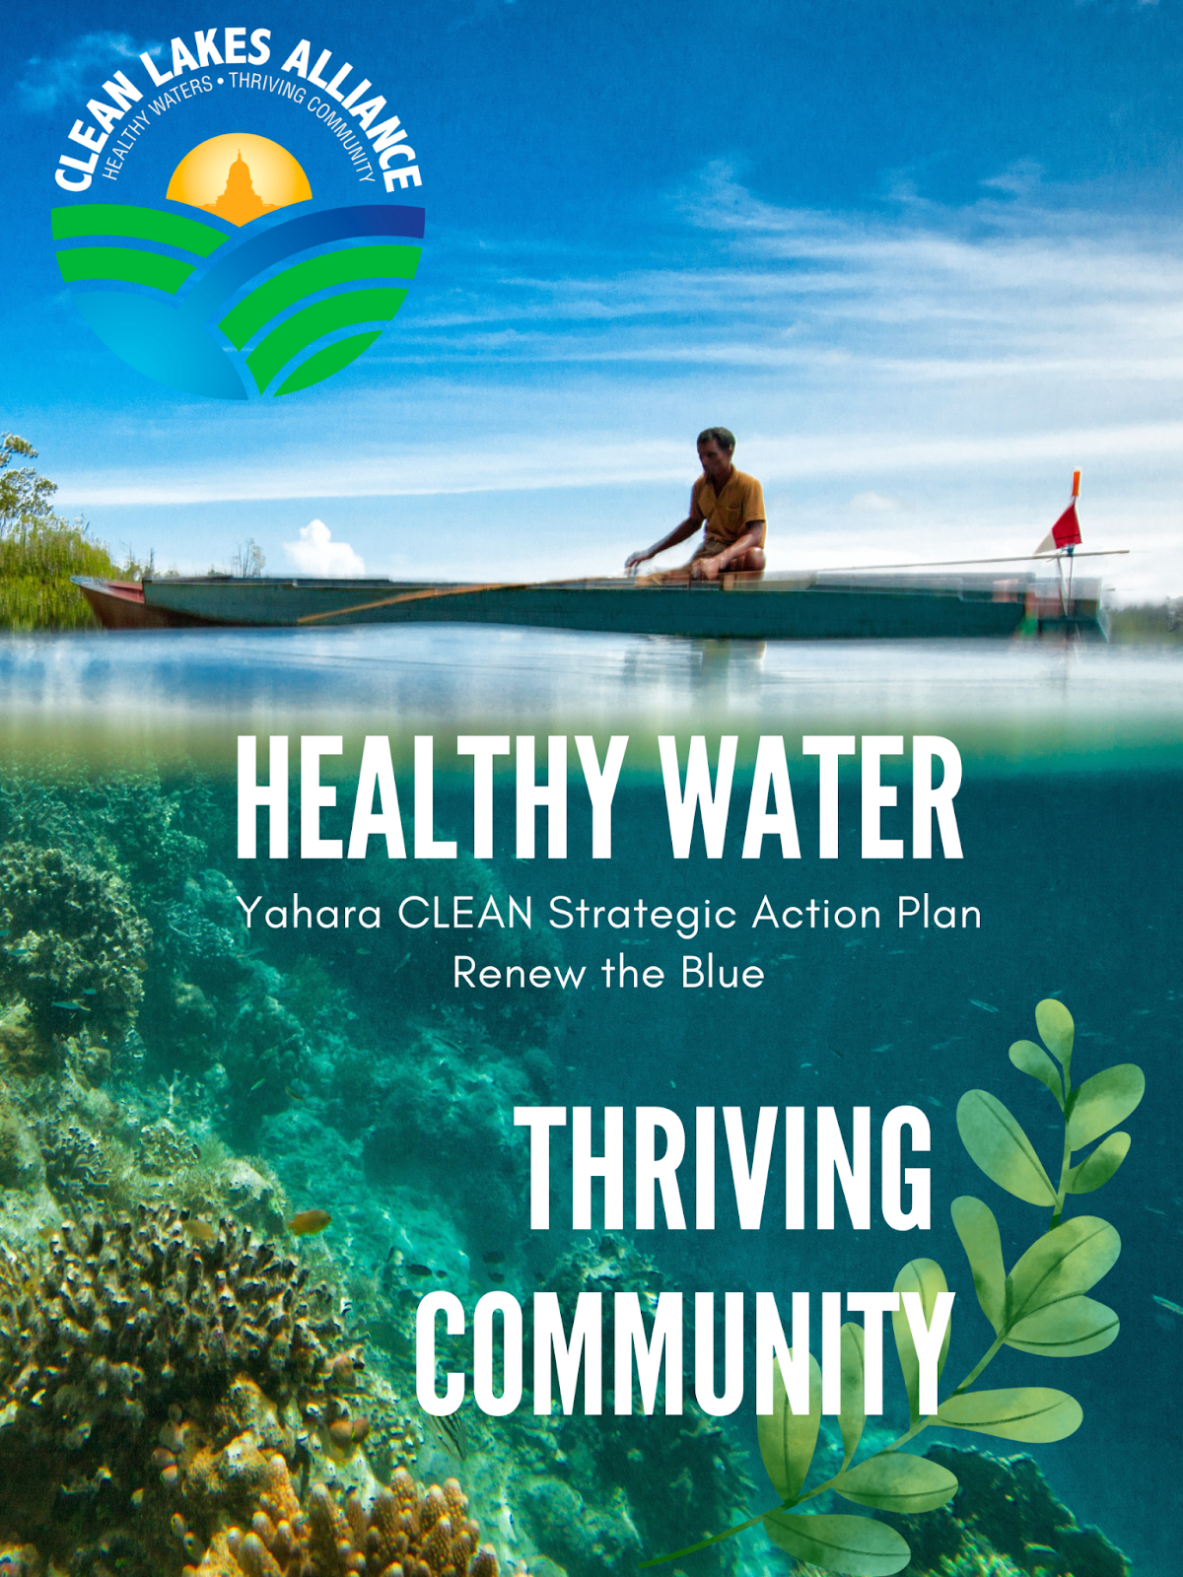
Canva

